
EIFL-FOSS Case Studies

Case Study: Nepal Evergreen ILS pilot

This case study was produced in June 2009 – an update from December 2010 is included at the end.
Project overview
The EIFL-FOSS ILS projects provided an opportunity for evaluation of (and possible migration to) a free and open source software (FOSS) integrated library system (ILS), to promote direct engagement with the FOSS communities of the chosen ILS and lay the groundwork for a mutual support network across the EIFL network for further libraries investigating migration to a FOSS ILS. The projects focused on evaluating one of two FOSS ILS tools with robust and open development and support communities: Koha (www.koha.org/) and Evergreen (www.open-ils.org/). Following a general call for participation in early 2008, several sites were selected that represented a wide range of libraries and regions. Each pilot library participating in the project was invited to participate in an intensive technical training workshop in Yerevan, Armenia, in June 2008.
Nepal Evergreen pilot
Background and selection of Evergreen
Madan Puraskar Pustakalaya (MPP http://madanpuraskar.org/) is a non-governmental, non-profit library. It maintains an archive of books, periodicals, ephemera, and other collections in the Nepali language which grew out of the personal collection of MPP's founder and chairman Kamal Mani Dixit. It holds 26,896 monographs, 5,136 periodicals, and a unique and rare collection of ephemera in the Nepali language. The main objectives of the library are to collect, preserve, catalogue, and provide access to the library materials for researchers and scholars. MPP has led the work on Nepali Unicode as well as NepaLinux. MPP currently uses an in-house cataloguing system with non-standard data (such as MARC21) which makes them dependent on in-house support and development, and unable to take advantage of new features in other systems. A move to a FOSS ILS would need a migration to a more standard format. MPP had already investigated Koha, and therefore opted to pilot the Evergreen ILS. Dibyendra Hyoju carried out the installation and testing under the direction of MPP Director Amar Gurung.

Initial installation
Dibyendra was unable to attend the training workshop in Armenia - instead Dibyendra established regular email contact with the workshop leader Dan Scott, Systems Librarian at Laurentian University in Canada to help explain and resolve any puzzling error messages that showed up during installation. The main problem MPP hit was with downloading the large number of PERL modules that comprise a large part of Evergreen - load shedding, or rolling blackouts, means that Kathmandu has electricity for only 8 hours per day, making downloading items that take several hours a difficult task.

Documentation and support
Documentation is not always perfect in FOSS projects. The more mature FOSS development projects have more substantial user and development communities who can make documentation a priority - documentation writing simply becomes part of the development cycle. In addition there are traditional community-based support mechanisms through public email discussion lists. Dibyendra may have been encountering problems that others had not yet encountered with the software. If so, then his public identification of these problems via the lists would have been a benefit to others who might face the same situation as well as a benefit to developers who might thereby be able to pinpoint a bug in the software.

Migration
The current MPP catalog consists of a unique MySQL schema designed to support an in-house cataloguing system used to record limited bibliographic data. A significant feature of this in-house system is that it supports versions of the records in Nepali and English. The challenge for migration is to transform these records into the MARC21 standard used by Evergreen, input them wholesale, and ensure that the full bibliographic information from the records is accessible in the pilot ILS. Dibyendra used the MarcEdit tool to migrate MPP’s data to the MARC21 format.

Learning Points from the pilot
There have been numerous learning points from this pilot. A few may be unique to MPP but most have wider application.
- Piloting requires sufficient dedicated time for mastering the key skills required for installing and using the software. A wide range of skills, especially Linux system administration skills, will be required.
- It may be best to undertake testing and piloting with a small team in order to share the learning and to help with overall support and morale.
- Large-scale systems migration will involve significant demands being placed on the available technical infrastructure.
- Use the public support channels of the FOSS project as your primary means of support in order to benefit yourself as well as the project. Review how to use them prior to embarking on a complex installation.
- Be aware that documentation – even installation documentation – may not always be 100% accurate or fully tailored to your installation.
- Migration from one library system to another is not an end in itself; it always serves the larger aims of the library.
2010 Update
At MPP, although the installation of Evergreen was successful, still issues remained with migration of records in MARC21 standard. Because of this the library decided from their earlier trial that Koha was the best FOSS option for their context. Records from the in-house ILS are being converted into MARC standard and imported into Koha – so far over 5,000 records have been migrated this way. When the migration reaches 10,000 records, MPP plans to open the OPAC for the system to the public.
For further information on Madan Puraskar Pustakalaya’s Evergreen activities, please contact Dibyendra Hyoju dibyendra@mpp.org.np.
For the full length Case Study see
http://www.eifl.net/system/files/201101/nepalcasestudy.pdf

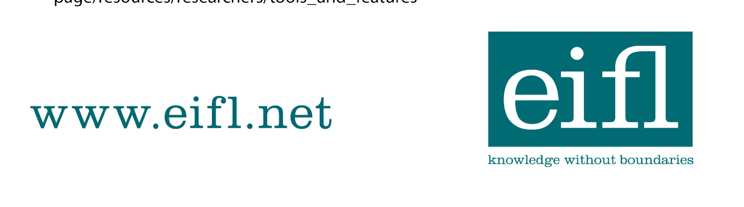

EIFL-FOSS Case Studies

EIFL-FOSS

