EIFL ANNUAL REPORT 2018

Case Study Kyrgyzstan

CASE STUDY – GULNAZ ZHUZBAEVA

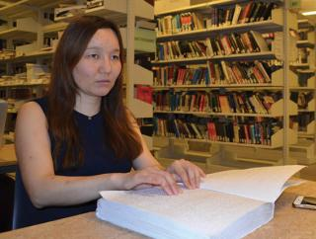

Gulnaz Zhuzbaeva is director of the Kyrgyz Federation of the Blind, which provides training for independent living for blind people. She is herself blind: “I am completing a master’s in business administration because I want to make our organization sustainable in future,” said Gulnaz.
However finding books in formats like braille, large print and audio, or accessible digital formats, was difficult.
“Copyright restrictions prevented me from getting most of the books I need,” said Gulnaz.
“Then in 2018 my university library was able to get a book, ‘The Lean Startup’, by Eric Ries in a format I can read, from a university in another country – because Kyrgyzstan had recently joined the Marrakesh Treaty.”
The Treaty provides the legal right to convert printed works into accessible formats for print-disabled people without having to ask permission from rightsholders, and to share them across borders. EIFL supported the Marrakesh Treaty advocacy campaign in Kyrgyzstan and helped to facilitate the transfer of the book from the University of Toronto in Canada.
On 23 April 2018, Gulnaz became the first student in Kyrgyzstan to receive an accessible format book from another country, as a result of the Marrakesh Treaty.
Quote from Gulnaz Zhuzbaeva:

“The Marrakesh Treaty is a great opportunity. When we cannot find books here in Kyrgyzstan we can request an accessible format copy from another country.”

